Non-printable parts
- Arduino Nano 3.0 ATMEGA328 CH340 with USB-C
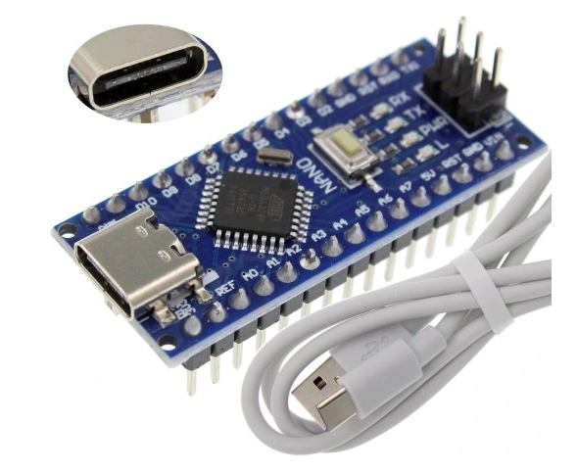
- DC Motor 3-6V with 1:48 gearing and double-sided shaft
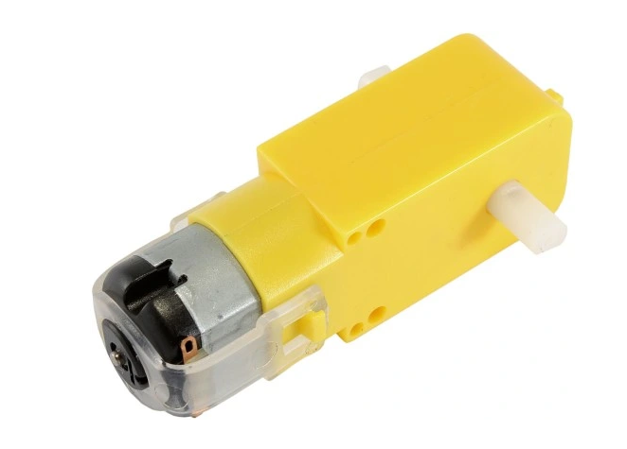
- Ultrasonic sensor HC-SR04
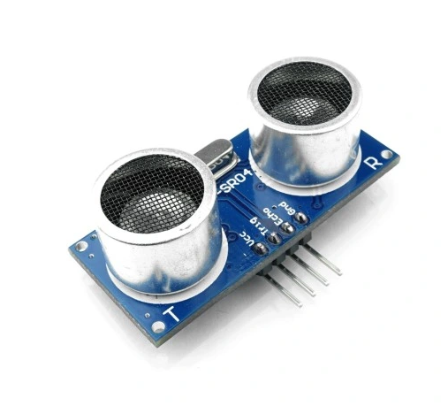
- HX1838 IR receiver
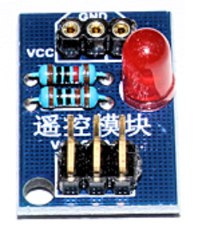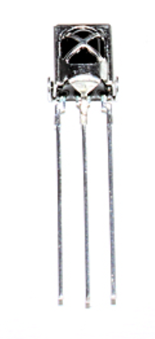
- L9110 / HG7881 Dual Channel Motor Driver
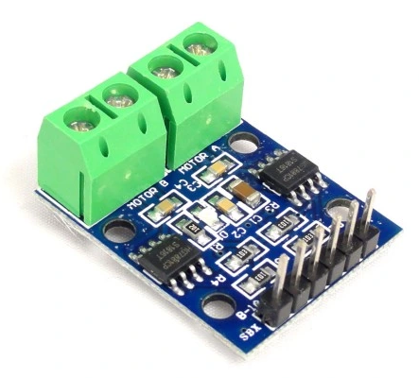
- Buzzer
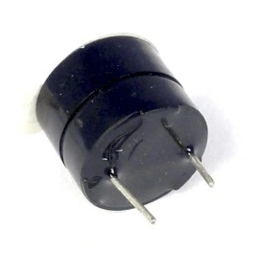
- SW-520D tilt sensor
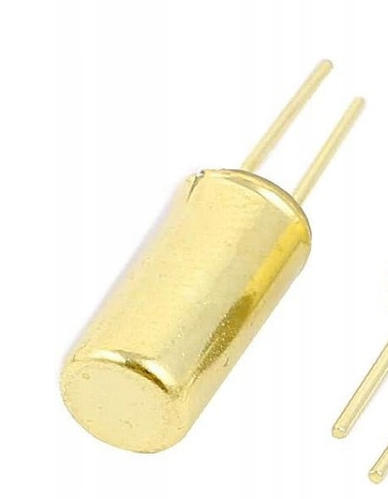
- 1 green LED
- 2 RGB LEDs
- Resistors for LEDs
- On/Off button
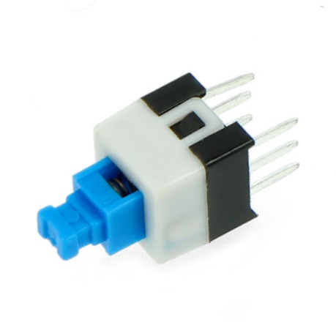
- Resistors for battery voltage measurements: 10K and 4.7K
- 2 x M3x30 screws with nuts
- Metal rods (3 mm for front wheel axle and 2 mm for top cover hinge)
- Round magnets for the lid (I used D4x2 mm magnets)
- Assembly screws (I had a bunch of 2x6 mm, 2x10 mmm, 2.5x8 mm screws)

